Broad Square Primary school: Managing allegations against staff and volunteers’ policy and procedures 2020-2021

This policy should be read alongside the DFE guidance Keeping Children Safe in Education and the Local Safeguarding Children Partnership’s policy and procedures.

The head teacher, Mrs Corbett is the designated case manager for allegations against all staff and volunteers. Ms. J Sloan (chair of governors) is the case manager for managing allegations against the head teacher.
The Local Authority Designated Officers in Liverpool are Ray Said and Pauline Trubshaw. They can be contacted on 0151 233 0840 or via email LADO@liverpool.gov.uk. Referrals should be made via Careline.
The purpose of this policy is to provide guidance to all staff and volunteers in relation to the processes for managing allegations against adults working with children.

Key principles:

- Any concerns about an adult’s behaviour towards a child or concerns about someone’s suitability to work with children, or behaviours that are inconsistent with the school’s code of conduct and guidance for safer working practices for working with children must be reported without delay in order to protect children. The school will not delay in seeking advice from the Local Authority Designated Officer or making a referral to Children’s Services or contacting the police.
- The school will work in partnership with other agencies to ensure any allegation is resolved in a timely way.

The school is aware of its statutory responsibility to make a referral to the Disclosure and Barring Service and/or the Teaching Regulation Agency when the outcome of a case requires this.

- In keeping with the DfE guidance Keeping Children Safe in Education any reference, including an agreed reference as part of a settlement agreement, will always include any substantiated allegations, safeguarding concerns and a statement about someone’s suitability to work with young people.
- The person should be given full opportunity to respond to the allegation and to participate in any investigation. The DfE is clear that compromise agreements where the person resigns and leaves with an agreed reference and the employer agrees not to pursue disciplinary action must not be used in cases of refusal to co-operate or resignation before the person’s notice period expires. Such an agreement will not prevent a thorough police investigation where that is appropriate. The school also has to investigate the matter in order to provide information to support any referral to the DBS or Teaching Regulation Agency.
- Consideration will be given as to how best to support all parties.
- Careful consideration will be given to alternatives to suspending the member of staff.
- The school is aware of its responsibility to maintain confidentiality and abide by the Education Act 2011 which places reporting restrictions preventing the publication of any material that might lead to the identification of a teacher until the person is charged or reporting restrictions are lifted. The school should make parents aware of their responsibilities in respect of confidentiality. Once the matter is concluded, careful consideration will be given to any lessons that can be learnt in particular induction, ongoing training, supervision, policies and procedures.
- If an adult who works with children has involvement from Children’s Social Care in respect of their own child, or a child that they live with or have contact with, it is the responsibility of Children’s Social Care to assess the immediate concern and inform the LADO of whether the adult poses a risk to children. Examples of this may include:
- Allegations of assault, physical or emotional, on their own child or on a child they live with or have contact with;
- Domestic abuse;
- Substance misuse; or
- Lives with or is in a relationship with a person who is identified as a risk to children
- Staff will be aware that behaviour by themselves, those with whom they have a relationship or association, or others in their personal lives (in or out of school or online), may impact on their work with children
- Staff will be aware that they should inform the head teacher of any cautions, convictions or relevant order accrued during their employment, and/or if they are charged with a criminal offence.
- Staff will be aware that if their role is within the scope of the Childcare Act 2006 and they commit a relevant offence that would appear on their DBS certificate or they become disqualified under the Childcare Act 2006, then they must inform their head teacher.
- In line with our code of conduct and child protection policy, staff in school should ensure that they disclose information about themselves relating to the above to the Head teacher as soon as possible. School will create an environment and culture where staff are able to do this.

Key procedures:

  - Any concerns about the behaviour of any adult working for the school towards a child should be brought to the attention of the Head Teacher (Mrs. Corbett) and/or Designated Safeguarding Lead (Mrs. Taylor) without delay. This includes supply staff and volunteers. Concerns about the headteacher should be directed to the chair of governors (Ms. Sloan).
  - Initial considerations should consider if the person may have:

  - behaved in a way that has harmed a child, or may have harmed a child;
  - possibly committed a criminal offence against or related to a child;
  - behaved towards a child or children in a way that indicates he or she would pose a risk of harm to children; or
  - behaved or may have behaved in a way that indicates they may not be suitable to work with children
Keeping Children Safe in Education 2020

  - Equally initial consideration may determine the concerns do not meet the above criteria and do not warrant a police investigation or enquires by Children’s Services. There may be clear evidence from the outset the allegation is false, malicious or unfounded.
  - Consideration should be given to immediately protecting the child and the need to contact the police.
  - The Local Authority Designated Officer is the linchpin in the process and should be contacted without delay to discuss allegations against staff and volunteers. The L.A.D.O. will hold a strategy discussion with police and relevant agencies. The strategy discussion and subsequent strategy meetings will consider:
    - the case for suspension or alternatives to suspension
- any investigation undertaken by police
- any assessment being undertaken by Children’s Services
- the basis for when the employer can begin a disciplinary investigation
- managing, sharing information and confidentially issues
- well-being and support needed for all parties
  - All referrals to Children’s Service should be made drawing upon the L.A.D.O. referral form.
  - The Case Manager should seek advice from their HR Provider and the Senior School Improvement Officer for Safeguarding.
  - When an allegation arises in an Early Years setting the Early Years Foundation Stage Framework may require the allegation to be reported to Ofsted (normally within 14 days).
  - The L.A.D.O. will advise if the parents and member of staff can be informed of the allegation and exactly what information can be shared.
  - At the point at which the member of staff is notified of the allegation they should be given information about the Managing Allegations Against Adults and Volunteers procedures and also a nominated member of staff to support them. They should be advised to seek Trade Union support and consideration should be given to their wellbeing and continued support. They should be given guidance about the process.
  - The L.A.D.O. will advise how to manage speculation, leaks and gossip and whether it would be prudent to contact the Local Authority Press Office, and any information which might be reasonably given to the community to reduce speculation. In line with Keeping Children Safe in Education, staff and the child’s family will be advised about the legislation on imposing restrictions which makes clear that the ‘publication’ of material that may lead to the identification of the teacher who is the subject of the allegation is prohibited.

The school will only begin a disciplinary investigation when advised by the L.A.D.O. and police that these processes can begin.

  - Suspension is always a neutral act and should not be an automatic response. The decision to suspend a member of staff is the employer’s only. However, the school will need to draw upon the advice of the L.A.D.O. and Police and, in keeping with the DFE guidance, record the reasons why suspension was chosen over other alternatives.
  - The case manager (Head Teacher or nominated governor) will record all actions, discussions and decisions taken in respect of the allegation. They will need to attend strategy meetings chaired by the L.A.D.O. They may wish to be accompanied by their HR Provider.
  - The DFE sets out the following definitions which should be used when determining the outcome of allegation investigations:

Substantiated: there is sufficient evidence to prove the allegation;
False: there is sufficient evidence to disprove the allegation;
Unsubstantiated: there is insufficient evidence to either prove or disprove the allegation. The term, therefore, does not imply guilt or innocence.
Malicious: there is sufficient evidence to disprove the allegation and there has been a deliberate act to deceive;
Unfounded: Schools may wish to use the additional definition of ‘unfounded’ to reflect cases where there is no evidence or proper basis which supports the allegation being made. It might also indicate that the person making the allegation misinterpreted the incident or was mistaken about what they saw. Alternatively, they may not have been aware of all the circumstances.

  - The school will only include in references substantiated allegations.
  - The school will retain information about substantiated, false, unfounded and unsubstantiated allegations on personnel files.
  - The record of the allegation will be retained until the member of staff’s normal retirement age or for a period of ten years from the date of the allegation if that is longer.
  - The school will consider what support the member of staff, child and family need throughout the process. In cases of malicious allegations, the school will consider whether disciplinary action is appropriate against the child or a referral to the police or Children’s Services is required.
  - On conclusion of the case the member of the staff will be given a copy of the outcome of the investigation and, where required, supported to return to work. The school has a legal duty to refer to the DBS in line with Keeping Children Safe in Education. The school will not enter into compromise/settlement agreements if a member of staff faces an allegation against them and the agreement prevents sharing concerns about someone’s suitability to work with children and/or the member of staff refuses to cooperate with the investigation (refer to detail of DFE guidance). The school would also still need to conclude its investigation and when required refer to the DBS for consideration of ‘barring from working with children’.
  - The school has a responsibility to refer to the Secretary of State (Teaching Regulation Agency) any teacher because of serious misconduct in line with Keeping Children Safe in Education.
- Consideration should also be given to how practices or procedures should be reviewed to help prevent similar events in the future, including the decision to suspend and the length of suspension.
- In some circumstances, the school will have to consider an allegation against an individual who is not directly employed by the organisation and where our disciplinary procedures do not fully apply (for example supply teachers). Whilst the school is not the employer of the individual, we still have responsibility to ensure allegations are dealt with properly and will liaise where appropriate with relevant parties. The school will not cease to use the services of a supply teacher as a result of safeguarding concerns, without finding out the facts and liaising with the LADO to determine a suitable outcome.

Summary: managing allegations against staff and volunteers’ procedures 2020-2021
If a member of staff or volunteer has a concern about the behaviour of another adult working in the setting then they should share this concern without delay with either:
- The Head teacher Mrs. Corbett (Case Manager for allegations against staff). If the Head teacher is unavailable: Deputy Head teacher/ Designated Safeguarding Lead, Mrs. Taylor.
- The Chair of Governors is the nominated Case Manager for allegations against the Head teacher.
Rarely a member of staff may need to contact Children’s Services or the Local Authority Designated Officer directly, or whistle-blow (NSPCC helpline 0800 028 0285 help@nspcc.org.uk)

A referral to Children’s Services is not required but consideration should be given to a disciplinary investigation. Contact your HR Advisor

Children’s Services should be contacted without delay to make a referral that will forwarded to the Local Authority Designated Officer (A L.A.D.O. referral form should be completed). Contact your HR Advisor.

The Local Authority Designated Officer (L.A.D.O.) can be contacted by the Case Manager for guidance. You can also discuss your concerns with HR Advisor or Senior School Improvement Officer.

The L.A.D.O will have a strategy discussion with police (and other agencies). This may lead to a strategy meeting chaired by the L.A.D.O typically involving the case manager (and HR representative), Police and a Social Worker. The strategy discussion or strategy meeting will include a discussion about:
- the case for suspension or alternatives to suspension
- any investigation undertaken by police
- any assessment being undertaken by Children’s Services
- the basis for when the employer can begin a disciplinary investigation
- managing, sharing information and confidentially issues
- well-being and support needed for all parties
Consideration given to:

- Supporting all parties
- Record keeping
- Outcome letter to member of staff
- Referral to DBS
- Referral to TRA
- Learning lessons to improve practice
- Feedback to the complainant (data protection consideration)
The Case Manager will then consider the alleged behaviour drawing upon Local Safeguarding Children Partnership Procedures and the DFE guidance Keeping Children Safe in Education. Did they:
- act in a way that has harmed a child, or may have harmed a child;
- possibly commit a criminal offence against or related to a child;
- behave towards a child or children in a way that indicates he or she would pose a risk of harm to children; or
- behave or may have behaved in a way that indicates they may not be suitable to work with children
Consideration should always be given to the need to immediately protect a child or children and contacting Children’s Services and/or Police without delay.

Managing Allegations Process 2020-2021

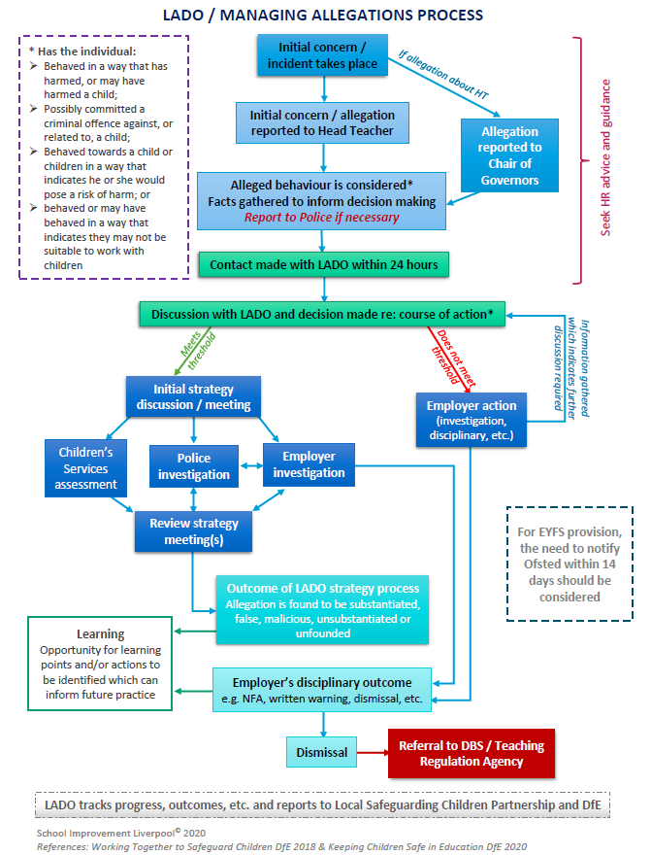
A guide for a member of school staff subject to an allegation that has been referred to the Local Authority Designated Officer for managing allegations against adults working with children

Any allegation is likely to cause anxiety and concern. This brief guide is to provide you with information if you are subject to an allegation. You can request a copy of the school’s Managing Allegations Against Staff procedures and you can also refer to part 4 of the DFE guidance Keeping Children Safe in Education. In addition, you can seek advice from your own union and refer to the Local Safeguarding Children Partnership procedures.

What happens when an allegation is made?

The case manager in school (headteacher) will consider whether the allegation needs to be referred to the police and/or children’s services because you may have:

- behaved in a way that has harmed a child or may have harmed a child;
- possibly committed a criminal offence against or related to a child;
- behaved towards a child or children in a way that indicates you would pose a risk of harm to children; or
- behaved or may have behaved in a way that indicates they may not be suitable to work with children

If from the outset there is evidence to suggest the allegation is unfounded, false or malicious then the headteacher will inform you that no further action will be taken and they will provide support to you. If the above criteria have not been met the school may still need to consider whether your actions or behaviour warrant further disciplinary consideration.

However, when the above criteria have been met the headteacher will need to refer the allegation to the Local Authority Designated Officer for consideration by children’s services and police. A strategy discussion and/or meeting will then take place to determine when you can be told about the allegation and what information you can be given. The strategy meeting will also consider any other children with whom you have significant contact, including your own children. It will also consider whether you need to be suspended from working with children. The decision to suspend you is your employer’s decision but they will need to take account of police and children’s services views. Alternatives to suspension should always be considered, drawing upon DFE guidance. If you are suspended, in line with your school’s disciplinary policy, you will be invited to a meeting to set out the suspension. However, the police and children’s services may have advised your school that they are unable to tell you the details of the allegation at this meeting.

Although you will not be able to discuss the allegation with members of the school community, a nominated member of staff will be appointed to liaise with you. They will keep you informed as to the progress of your case. You may be offered counselling services and/or support from occupational health. You should always contact your GP if you feel your health is being affected. You will be advised about the responsibilities of all parties in respect of confidentiality. You should seek advice from your union or professional body from the outset.

If police and children’s services decide to take no further action your school may still need to undertake a disciplinary investigation.

Your school are not able to agree to any reference that does not include any substantiated allegations or comment on your suitability to work with children or any safeguarding concerns. The school will always need to conclude its investigation and even if you choose to resign you will be invited to participate in the investigation. The DFE statutory guidance makes it clear the circumstances in which the school will not be able to enter into settlement/compromise agreement.

Your school may have a statutory responsibility to make a referral to the Disclosure and Barring Service and/or Teaching Regulation Agency.

This document can be provided in different formats upon request.
The policy has been shared with governors and will been reviewed annually by L.A to address national changes.

Date: September 2020
Signed: V. Corbett (Headteacher)
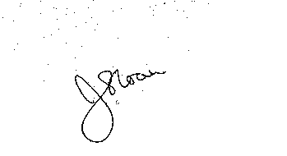
Signed: J. Sloan (Chair of Governors)

