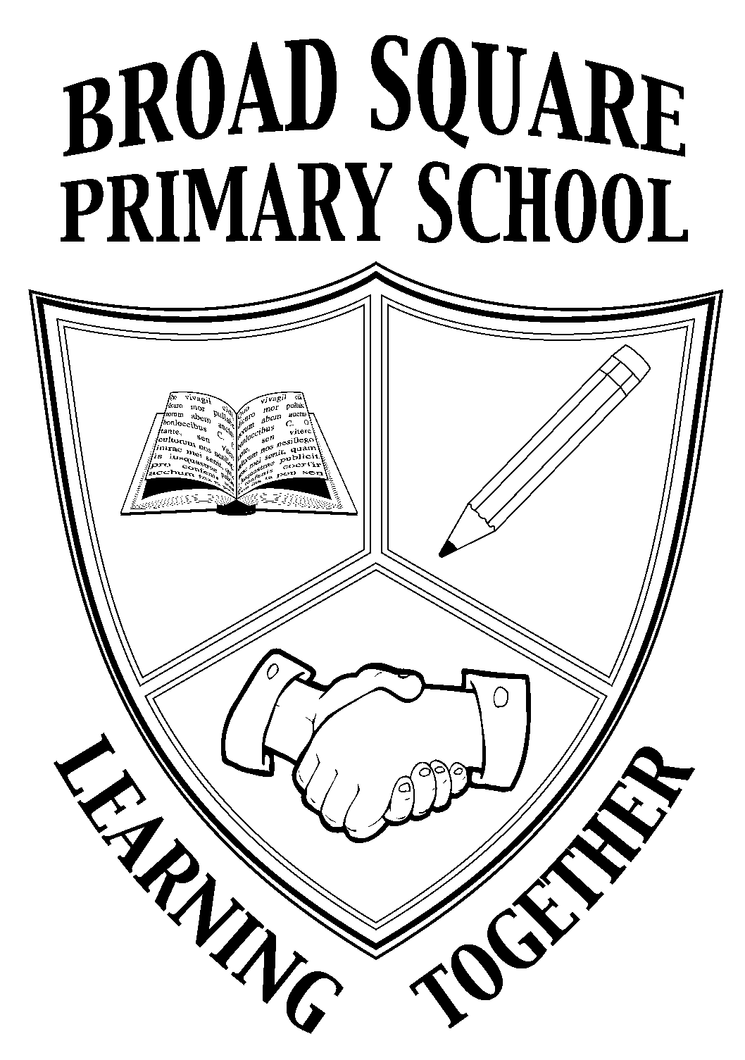

BROAD SQUARE PRIMARY SCHOOL
BROAD SQUARE
LIVERPOOL

L11 1BS
TELEPHONE No. 0151 226 1117
Website: www.broadsquareprimary.co.uk
Email: office@broadsquare.liverpool.sch.uk

Headteacher: Mrs. Victoria Corbett

HOME SCHOOL AGREEMENT

September 2021

Working in Partnership for Success
We all agree to live by our school values of
Respect, Compassion, Perseverance, Community, Excellence, Enjoyment and Responsibility

School

The Learning Environment
Our school will:
- Provide your child with a high standard of education, implemented by rigorous national guidelines, within a balanced curriculum.
- Ensure that our learning environment is stimulating and challenging.
- Celebrate your child’s academic and personal achievements.
- Provide the scaffolding needed to enable your child to achieve their full potential.
- Care for your child’s safety and well-being by observation and listening

A Healthy, Happy Community
Our school will:
- Teach your child to develop a positive attitude to one another, regardless of gender, race, culture, belief, values, age and need.
- Encourage your child to become an active member within our community and help them to see that they can have an impact on the world around them.
- Regularly meet with you to communicate the progress of your child, celebrating their strengths and explaining how we can support them in their areas for development.
- Provide information to you about our school, including relevant policies, meetings, workshops, activities, newsletters and open days.
- Be very happy to welcome you if you would like to contribute to our school’s broader curriculum. We recognise that the community of Broad Square holds a wealth of talent, experience, diversity and enthusiasm that our school could benefit richly from.
Home Learning
The school will:
- Set challenging yet achievable homework to extend the curriculum and provide the opportunity for independent learning. Clear information will be provided so that you will be able to help your child if required.
- Provide information and helpful curriculum café sessions for you that will give you confidence to support your child.
- Will make contact with families and provide a tailored remote curriculum in the event of isolation or school closure due to COVID 19.
- Provide work books and home learning books to support working from home.

Parents/Carers

The Learning Environment
As a Parent/Carer I will:
- In order to help my child gain the most of their education, make sure my child arrives at school on time, every day they possibly can, so that they are prepared to start their lessons. They will be wearing named school uniform and that their PE kit is worn on the days that they are scheduled to do PE.
- Do my very best to provide a safe, secure and happy environment at home for my child, acknowledging that they learn at home.

A

Healthy, Happy Community
As a Parent/Carer I will:
- Let the school know of any concerns or worries that may be affecting my child’s learning, behaviour or ability to do home learning, as this can then be resolved quickly and positively.
- Support the school by encouraging my child to develop a positive attitude towards our diverse community.
- Attend meetings with my child’s teacher and other staff, aiming to be positive and productive, working towards moving my child on in their learning. In current circumstances, this may be a telephone conversation or a meeting online.
- Support and work with you to ensure that the behaviour policies of the school are maintained, particularly with my child.
- Encourage a positive attitude towards my child’s education and our school. If I have any concerns, I will discuss them with you at the earliest opportunity as it is much healthier to work out solutions and move on.
- Read all information sent home as this gives me important details of relevant policies, meetings, workshops, activities, newsletters and open morning events. This includes weekly newsletters and documents send electronically via MyEd.

Home and Remote Learning
- Please support the school by making sure that home learning tasks are completed and returned on time.
- Please use your talents and experiences to enhance your child’s learning at home. Your child will benefit greatly from what you can show them, discuss with them and teach them.
- In the event of school closure or isolation due to COVID 19, if medically well, you will help your child engage in daily lessons provided by the teachers in order for them to still make progress. If teachers or other staff members contact you, you will speak to them and do as much as you can to help us so that we can provide a continuous education for your child.

Pupils
I understand that I have rights within the school, some of which are:
To be treated kindly; listened to and helped; to have a friend; to play and join in games; to be happy; to feel wanted; to be safe; to be special.

I will:
- Respect other children’s culture, race, feelings, beliefs and values.
- Accept responsibility for the things that I do.
- Be responsible for my school, the effort I put into learning every day and home learning.
- Ask for help if I need it and try my best in all that I do.
- Ensure I take home my reading book and any letters.
- Be kind and speak politely to everyone in school and in any communication with others that I may have, including online.
- Take good care of the building, equipment (including resources provided for home learning) and school grounds.
- Behave in a safe way.
- Be helpful.
- Tell a member of staff if I am worried or unhappy.

SIGNED: (Parent)

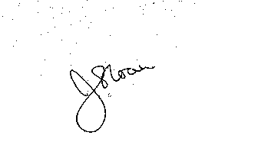
SIGNED: (Child)


SIGNED: (School) Headteacher Chair of Governors

Date:

