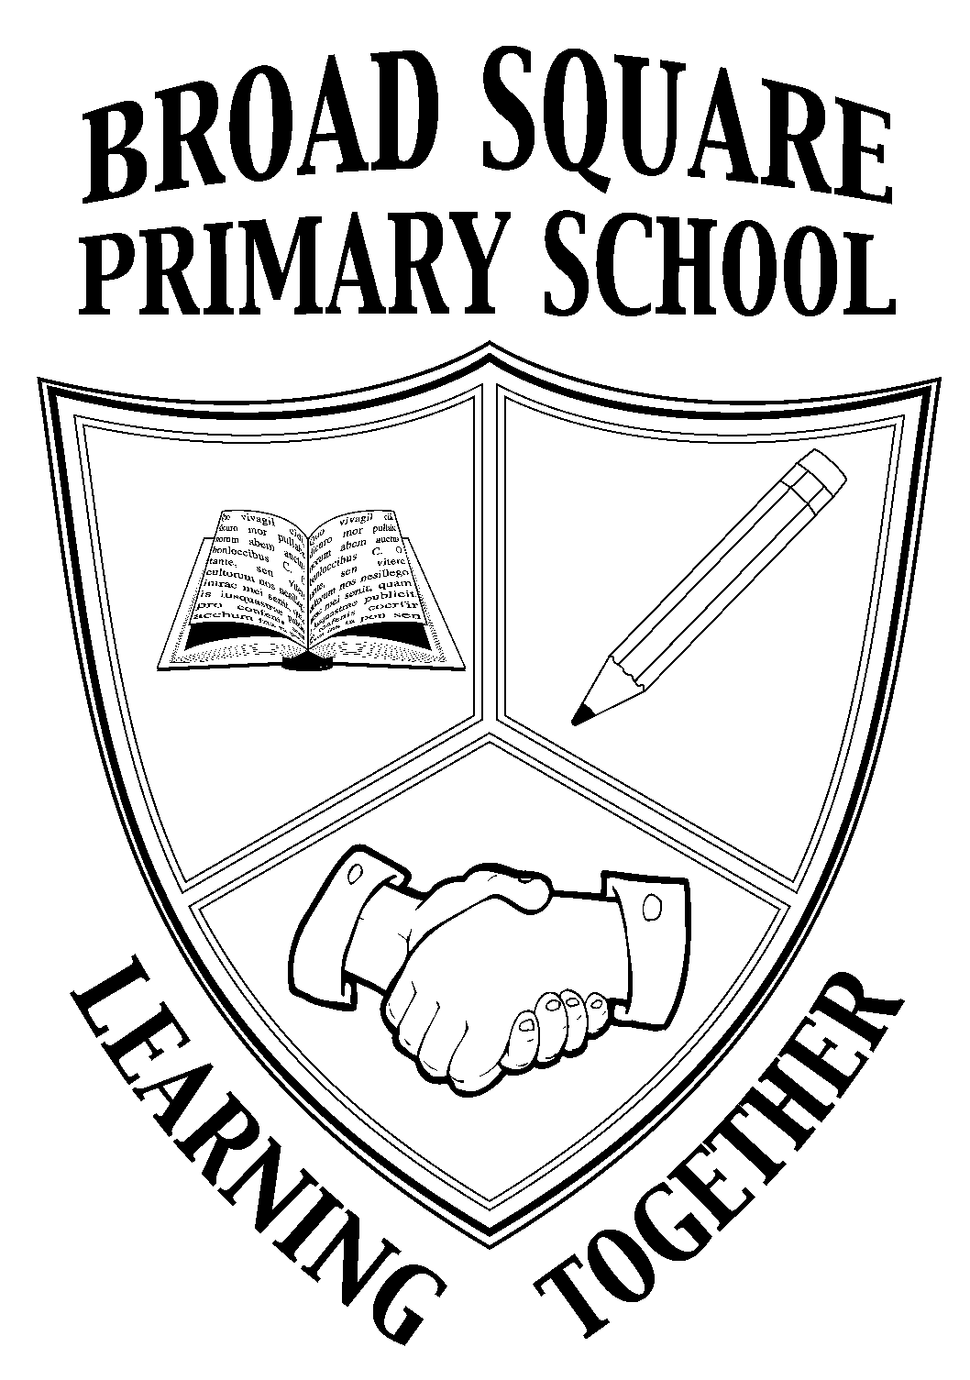

BROAD SQUARE PRIMARY SCHOOL
BROAD SQUARE
LIVERPOOL

L11 1BS
TELEPHONE No. 0151 226 1117
Website: www.broadsquareprimary.co.uk
Email: office@broadsquare.liverpool.sch.uk

Headteacher: Mrs. Victoria Corbett

RELATIONSHIP AND SEX EDUCATION (RSE)

As of September 2020 all primary schools will be required to have Relationships and Health Education in place.

As a maintained school we have an obligation to teach children from Year 1 to Year 6 about aspects of RSE. The mention of the words, ‘Sex education’ can create unnecessary anxiety for parents and carers and we want to reassure you that the focus of much RSE in primary school is broader than you might think, focussing more so on the Relationships rather than the Sex aspect. RSE is learning about the emotional, social and physical aspects of growing up, relationships, sex and human sexuality. Some aspects are taught in science, and others are taught as part of personal, social, health and economic education (P.S.H.E).
The aim is to provide pupils with accurate information about the bod and reproduction as well as the essential skills needed for building positive, enjoyable, respectful and non-exploitative relationships and staying safe both on and offline.

THE LEGAL POSITION FOR SRE
Relationship Education and Health Education are now statutory in all Primary Schools in England and children CANNOT be withdrawn from these lessons. SRE plays an important part in fulfilling the statutory duties all schools have to meet.
- SRE plays a vital part in meeting schools’ safeguarding obligations. Ofsted is clear that schools must have a preventative programme that enables pupils to learn about safety and risks in relationships.
- Schools maintain a statutory obligation under the Children Act (2004) to promote their pupils’ wellbeing and under the Education Act (1996) to prepare children and young people for the challenges, opportunities and responsibilities of adult life.
- Under section 78 of the Education Act 2002 and the Academies Act 2010, a P.S.H.E curriculum should promote the spiritual, moral, cultural, mental and physical development of the pupils and prepare them for the opportunities, responsibilities and experiences of later life.
- In the recent review of the National Curriculum, the government has made it clear that all state schools ‘should make provision for personal, social, health and economic educations (PSHE) drawing on good practice’ (National Curriculum in England, DfE, 2013) and that ‘sex and relationship education (SRE) is an important part of PSHE education’ (Guidance – PSHE education, DfE, 2013).
- The Department of Health set out its ambition for all children and young people to receive high quality SRE in the Sexual Healthy Improvement Framework (2013).
- The DfE’s paper The Importance of Teaching (2010) highlighted that ‘Children need high quality SRE so they can make wise and informed choices’.

TEACHING AND LEARNING
In Summer Term 2, RSE is delivered in a clear, concise and consistent manner in line with national and local guidelines and using a comprehensive Scheme of Learning for P.S.H.E. (Jigsaw). Whilst the core SRE content is delivered through the ‘Changing Me’ Puzzle, essential work is done in previous puzzles to build children’s self-esteem, to enhance their own sense of self in regard to their body image, how to develop caring and healthy relationships and how to develop assertiveness skills in keeping themselves valued, safe and respected. This work underpins the explicit SRE content and is part of the holistic approach to SRE teaching and learning.

YEAR GROUP | ATTAINMENT DESCRIPTORS
YEAR 1  YEAR 2 | I know that boys and girls are different.  I know that some parts of my body are private.  I respect my body.  The above statements should be covered when it is meaningful and relevant for the cohort.
YEAR 3 | I can correctly name the main parts of the body that make boys and girls different and I know these are parts we keep private.
YEAR 4 | I can tell you some of the ways that boys’ and girls’ bodies change on the inside as they grow up, and I know these changes are connected to making babies.  I can tell you something I like and something that worries me about the idea of growing up.
YEAR 5 | I can identify some changes that happen to girls’ and boys’ bodies during puberty.  I know my body will change during puberty and I can tell you how I feel about this.
YEAR 6 | I can identify the main stages by which a baby develops through conception, pregnancy and birth and can tell you some words that describe my feelings about this.

PARENTS / CARERS WITHDRAWAL
To be clear, where parents once had the choice to remove their child from all RSE lessons each year, the vast majority of what is now required of schools is statutory and must be taught to all pupils. You cannot withdraw your child from Relationships and Health Education because it is important that all children receive this content, covering topics such as friendships and how to stay safe.

As a parent or carer you do have the right to request your child is removed from parts of the sex education programme, but we feel confident that the content is both relevant and appropriate for the different age groups. Jigsaw has deemed that only 3 lessons are considered as ‘human reproduction’ and therefore only these lessons children can be withdrawn from. One lesson in YR4 ‘having a baby’, one lesson in YR5 ‘conception’ and one lesson in YR6 ‘conception to birth’. It is important to clarify that withdrawal of your child would only be considered only for content that is not part of the statutory science curriculum.

Parents are welcome to make an appointment with the PSHE co-ordinator to talk more in detail about the topic and any concerns you may have. To help you understand what will be taught from September 2020 a concise overview of content by year group has been uploaded to the school website, along Jigsaw leaflets outlining further detail

Yours sincerely
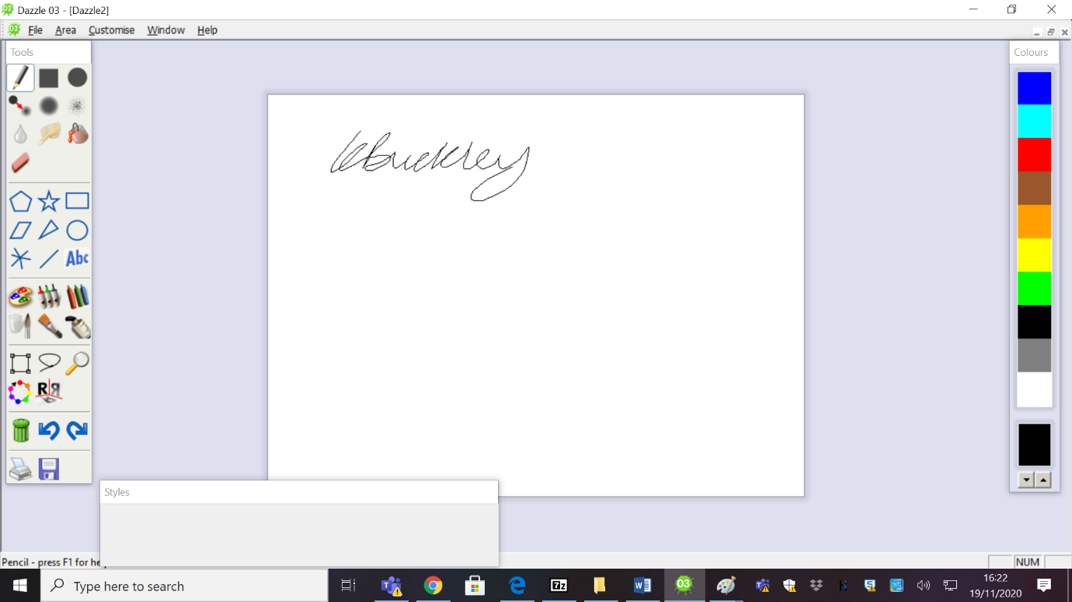

K. Buckley
PSHE Coordinator

